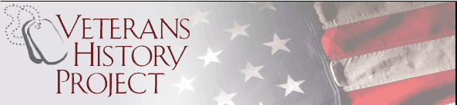
MISSION

The Veterans Memorial Center (VMC) offers a special Veterans History Project (VHP) in coordination with the American Red Cross and Library of Congress (LOC) at no charge. The VHP mission is to collect, preserve, and make accessible the personal accounts of American veterans of all services and periods of history. Thus, future generations may hear directly from veterans and better understand the realities of war and other military service. After the recorded interview the veteran and family will receive their own DVD, one will be kept at the VMC library, and electronic copies will be downloaded to the LOC.

TO PARTICIPATE
If you are a veteran, simply contact us and we will arrange a video recorded interview in the VMC library or, in special cases, at your home. The conversation can last thirty minutes or two hours. That is up to you. The story can include your service and how your life was spent after the military. Remember hundreds of veterans have told their stories which are preserved forever on VHP DVD’s at the VMC Library and LOC.

CONTACT US
To arrange an appointment please contact:
Donn Weaver 757-871-6576 donnweaver2020@gmail.com
Jim Pirotti 732-690-8353 Jim.P-Midstate@hotmail.com

VIDEOGRAPHERS
Paul Julian 321-452-9414 pjulian54@gmail.com

